**Experiment No. 9**

Aim: Application of COCOMO model for cost estimation of the project.

Theory:

The COCOMO (Constructive Cost Model) is one of the most popularly [used software cost estimation](https://www.educba.com/software-cost-estimation/) models i.e. it estimates or predicts the effort required for the project, total project cost and scheduled time for the project. This model depends on the number of lines of code for software product development. It was developed by a software engineer Barry Boehm in 1981.

The COCOMO estimates the cost for software product development in terms of effort (resources required to complete the project work) and schedule (time required to complete the project work) based on the size of the software product. It estimates the required number of Man-Months (MM) for the full development of software products. According to COCOMO, there are three modes of software development projects that depend on complexity. Such as:

1. Organic Project: It belongs to small and simple software projects which are handled by a small team with good domain knowledge and few rigid requirements. Example: Small data processing or Inventory management system.
2. Semidetached Project: It is an intermediate (in terms of signs and complexity) project, where the team having mixed experience (both experience and inexperience resources) to deal with rigid/non rigid requirements. Example: Database design or OS implementation
3. Embedded Project: This project having a high level of complexity with a large team size by considering all sets of parameters(software, hardware and operational).

Types of COCOMO mode:

1. The basic COCOMO: It is the one type of static model to estimates software development effort quickly and roughly. It mainly deals with the number of lines of code and the level of estimation accuracy is less as we don’t consider the all parameters belongs to the project. The estimated effort and scheduled time for the project are given by the relation: Effort (E) = a*(KLOC)b MM  
Scheduled Time (D) = c*(E)d Months(M) Where, **E =** Total effort required for the project in Man-Months (MM).

* **D =** Total time required for project development in Months (M).
* **KLOC =** the size of the code for the project in Kilo lines of code.
* **a, b, c, d** **=** The constant parameters for a software project.

2. The intermediate COCOMO: The intermediate model estimates software development effort in terms of size of the program and other related cost drivers parameters (product parameter, hardware parameter, resource parameter, and project parameter) of the project. The estimated effort and scheduled time are given by the relationship: Effort (E) = a*(KLOC)b*EAF  MM  
Scheduled Time (D) = c*(E)d Months(M) Where,

* **E =** Total effort required for the project in Man-Months (MM).
* **D =** Total time required for project development in Months (M).
* **KLOC =** The size of the code for the project in Kilo lines of code.
* **a, b, c, d =** The constant parameters for the software project.

3.The detailed COCOMO: It is the advanced model that estimates the software development effort like Intermediate COCOMO in each stage of the software development life cycle process.

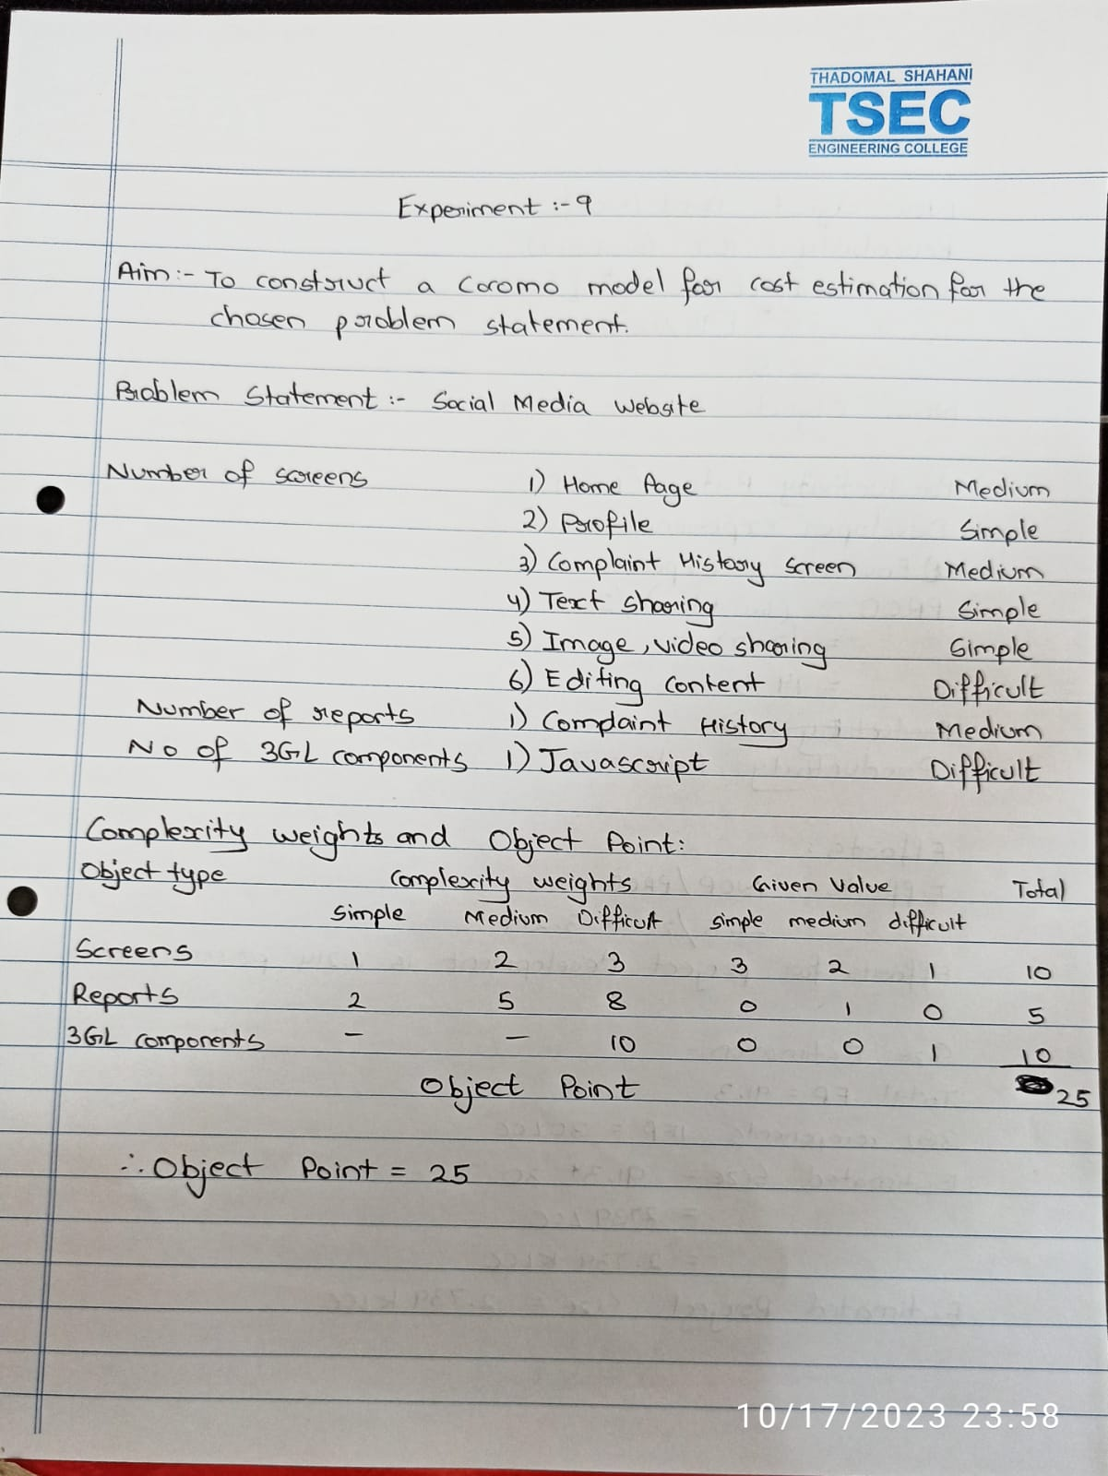



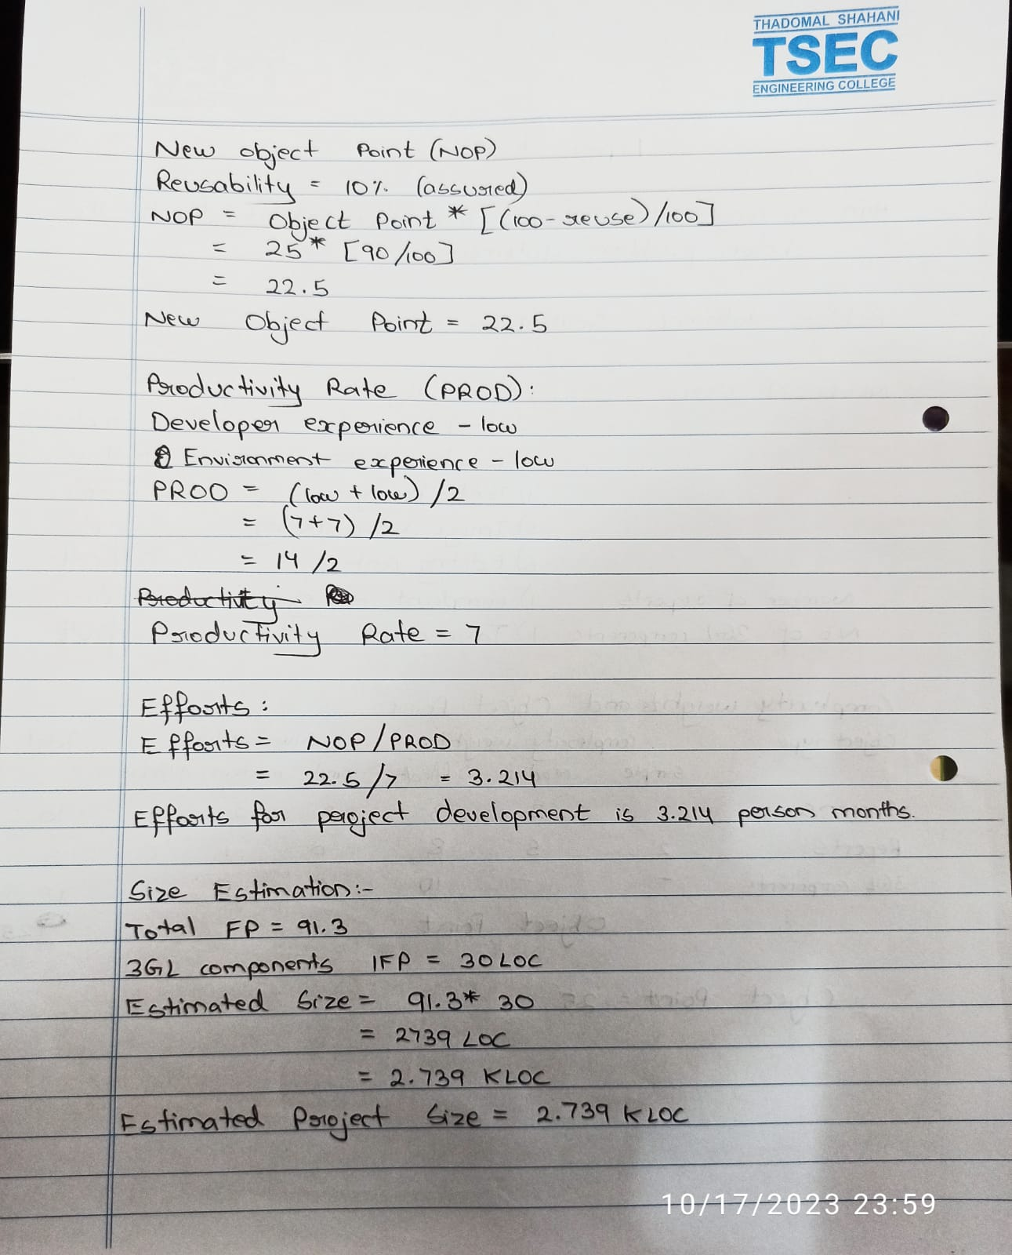

**Conclusion:** Hence, we have understood the implementation of COCOMO model